Bash Lab

**Part 1: Understanding Base64 Encoding**

Step 1: Introduction to Base64

Base64 encoding is a widely used technique that converts binary data into an ASCII string format, ensuring that data remains intact during transmission over text-based systems. This encoding scheme is particularly useful in applications where binary data must be stored or transferred through systems that only support text. The key principle of base64 is that it encodes every three bytes of binary data into four bytes of encoded text, allowing for safe transport while increasing the data size by approximately 33%.

**Part 2: Encoding Data with Base64**

Step 2: Encode a String



When encoding a simple string like "Hello, World!", the transformation process converts each character into a binary format and then maps these binary values into a base64 table. The resulting encoded string ensures that the original data can be represented using only printable characters. The output, "SGVsbG8sIFdvcmxkIQ==", is easily reversible, confirming that base64 is a lossless encoding method. Similarly, when encoding binary files, the conversion process represents raw bytes as ASCII text, making it suitable for embedding images or executable files into text-based environments.

Step 3: Encode Binary Data



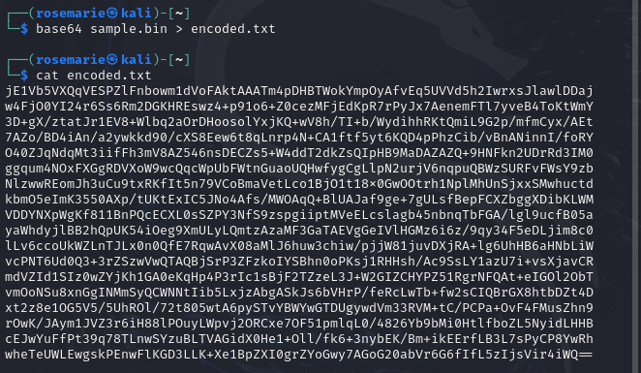

Decoding base64-encoded data is a straightforward process that reverses the transformation. For example, decoding "SGVsbG8sIFdvcmxkIQ==" successfully restores "Hello, World!", demonstrating the reversible nature of base64. Similarly, when decoding a previously encoded binary file, verifying its integrity using the diff command confirms that no data was lost or altered during encoding and decoding. The ability to accurately restore the original file ensures that base64 encoding is a reliable technique for text-based data transfer.

**Part 3: Decoding Base64 Data**

Step 4: Decode the Base64-encoded String



The decoded pattern is the same as the one previously did above

Step 5: Decode the Binary Data



Since the diff command returns no output, it means that the files are identical.

**Part 4: Practical Applications and Security Considerations**

Step 6: Discuss Practical Uses

Base64 encoding has a variety of real-world applications. It is commonly used in email systems to encode attachments, allowing binary files to be transmitted over text-based protocols. In web development, base64 is frequently employed to encode images and assets in HTML or CSS files, reducing HTTP requests. Additionally, digital certificates and cryptographic keys often use base64 encoding for storage and transmission in formats like PEM. These applications highlight the necessity of base64 in handling non-textual data in text-restricted environments.

Step 7: Discuss Security Implications

It is essential to recognize that base64 is an encoding mechanism rather than an encryption method. Unlike encryption, which secures data against unauthorized access, base64 merely transforms data into a different format that can be easily decoded. This means that base64 should not be used for security purposes, such as protecting sensitive information. Instead, it is primarily useful for ensuring compatibility across different systems that might not handle raw binary data effectively. For secure data transmission, encryption techniques such as AES or RSA should be used instead of base64 encoding.

**Part 5: Lab Reporting**

Through this lab, the process of encoding and decoding data using base64 has been thoroughly explored. By encoding simple text and binary files, we observed how base64 transforms data into a safe, text-based format, allowing for seamless transmission and storage. The verification process using decoding and file comparison reinforced the reliability of base64 encoding. However, understanding its limitations—particularly its lack of security—emphasizes the importance of using encryption for sensitive data. This lab has provided valuable insights into data encoding and its role in modern computing systems.